Site map for
Senior Food Box Distribution @ Community Outreach Connection
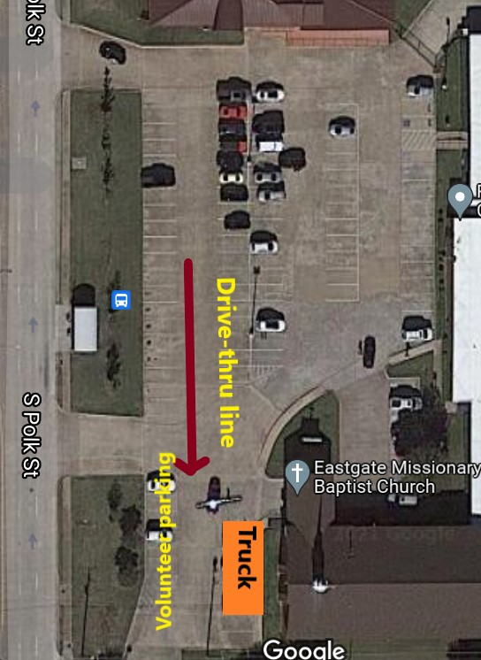
Site Contacts
- NTFB Senior Program Team
  - Rowena Roberson – (214) 882-2447
  - Teresa Hernandez – (214) 470-8603
  - Jennifer Davila – (214) 883-2622

